Ethical RAG: Preventing AI Hallucinations in Medical Domains
CS 517: Socially Responsible AI - Final Project Report
Group Members: Soureesh Dalal, Abhishek Basu, Sai Teja, Sai Rohit
Group Leader: Soureesh Dalal
1. Introduction
Large Language Models (LLMs) enhanced with Retrieval-Augmented Generation (RAG) have shown remarkable capabilities in many domains. However, in high-stakes fields like healthcare, finance, legal, etc, these systems often generate incorrect or unverifiable information—a phenomenon known as "hallucination." This poses significant risks when AI-generated misinformation can lead to misdiagnosis, incorrect treatment recommendations, or loss of trust in AI healthcare tools.
Our project addresses this critical issue by developing an "Ethical RAG" system specifically designed for medical applications. This system incorporates three key components to reduce hallucinations:
Trustworthiness-weighted retrieval using authoritative medical sources
Self-consistency verification to detect and flag potentially hallucinated responses
Hybrid retrieval architecture combining BM25 and dense vector embeddings for more relevant document selection
The ethical implications of our work extend beyond technical performance, addressing fundamental concerns about AI safety and reliability in healthcare. By providing transparency about information quality and uncertainty, our system represents a step toward more responsible AI deployment in medical domains.
2. Problem Definition and Background
2.1 Hallucinations in Medical AI
LLMs trained on internet-scale data often generate plausible-sounding but factually incorrect information. In the medical domain, this poses serious risks:
Incorrect treatment recommendations could lead to patient harm
Misdiagnosis suggestions could delay proper care
Fabricated medical research citations undermine scientific integrity
Undetected misinformation erodes trust in AI healthcare tools
Standard RAG systems attempt to address hallucinations by grounding LLM outputs in external knowledge bases. However, these systems have limitations when applied to medical domains:
They don't evaluate source trustworthiness (treating all documents equally)
They lack mechanisms to detect when retrieved information is insufficient
They don't verify response consistency across related queries
They rarely communicate uncertainty to end users
2.2 Ethical Considerations
Our project considers several ethical dimensions:
Safety: Preventing harmful medical misinformation
Transparency: Communicating confidence levels to users
Fairness: Ensuring reliable information across medical conditions
Accountability: Providing traceable sources for generated information
Trust: Maintaining confidence in AI-assisted medical tools
3. Approach and Methodology
Our Ethical RAG system extends standard RAG architectures with three key components: trustworthiness evaluation, self-consistency verification, and hybrid retrieval. Each component addresses specific ethical and technical challenges in medical information retrieval.
3.1 Dataset Preparation
We utilized the PubMed Central Open Access (PMC-OA) dataset, which contains peer-reviewed medical research articles. Our preprocessing pipeline included:
Extracting articles with titles, abstracts, and full-text content
Chunking documents into manageable sections for retrieval (1000-character chunks with 200-character overlap)
Ensuring critical information like title and abstract remained together
Generating unique identifiers for each article and chunk
Preserving source metadata for trustworthiness assessment
The processed dataset contained 500 medical articles chunked into approximately 2,500 text segments across various medical domains.
3.2 Hybrid Retrieval Architecture
To improve retrieval relevance, we implemented a hybrid approach combining:
BM25 Retrieval:
Sparse lexical matching using the rank-BM25 library
Document tokenization with stop word removal and stemming
Efficient retrieval based on term frequency and inverse document frequency
Vector Retrieval:
Dense semantic matching using ChromaDB and sentence-transformers
Embedding generation with all-MiniLM-L6-v2 model
Cosine similarity-based document ranking
The hybrid retrieval function combines scores from both methods:
hybrid_score = α * bm25_score + (1-α) * vector_score
where α = 0.6, giving slightly more weight to lexical matching due to the precise terminology in medical texts.
3.3 Trustworthiness Scoring
A novel contribution of our work is the medical source trustworthiness scoring system, which evaluates information quality based on:
Journal Reputation: Assigning higher scores to established medical journals (e.g., NEJM, JAMA, Lancet)
Citation Patterns: Identifying standard academic citation formats as indicators of reliability
Academic Structure: Recognizing formal section headings (Methods, Results, etc.)
Publication Date: Giving preference to more recent sources when appropriate
Author Credentials: Considering institutional affiliations when available
We implemented this as:
trustworthiness = base_score + journal_score + academic_score + abstract_bonus + pmc_id_bonus
The final score is capped at 0.95 (reserving 1.0 for human expert verification).
3.4 Self-Consistency Verification
To detect potential hallucinations, we developed a novel approach that tests result consistency across query variations:
Query Variant Generation: Creating semantically equivalent variations of the original query (e.g., "diabetes symptoms" → "clinical manifestations of diabetes mellitus")
Multiple Retrieval Runs: Performing separate retrievals for each variant
Consistency Analysis: Measuring overlap in retrieved documents across variants
Hallucination Risk Assessment: Computing a consistency score and mapping it to risk levels:Low risk (score ≥ 0.7)
Medium risk (0.5 ≤ score < 0.7)
Medium-high risk (0.3 ≤ score < 0.5)
High risk (score < 0.3)
This approach is particularly effective for detecting "knowledge gaps" where the LLM might otherwise hallucinate information.
3.5 Response Generation with Confidence Levels
The final component synthesizes the trustworthiness and consistency evaluations to:
Filter retrieved documents using a minimum trustworthiness threshold (0.6)
Identify documents that appear consistently across query variants
Generate a response using the filtered, consistent documents
Include appropriate warnings based on the hallucination risk level
Visually mark responses with confidence indicators:
🟢 HIGH CONFIDENCE (Low risk)
🟡 MEDIUM CONFIDENCE (Medium risk)
🔴 LOW CONFIDENCE (Medium-high or High risk)
4. Experimental Results
We evaluated our Ethical RAG system against a standard RAG baseline across four medical domains: diabetes, cardiovascular, neurology, and general medicine.
4.1 Overall Performance Comparison
Our experiments demonstrated that the Ethical RAG system achieved:
Higher trustworthiness: Average document trustworthiness increased from 0.65 to 0.82 (+26.2%)
Effective hallucination detection: 66.7% of queries were classified as low risk, 33.3% received appropriate warnings
Minimal retrieval overhead: The additional components added only 0.15 seconds to the average retrieval time
Similar document relevance: Both systems retrieved approximately 5 documents per query, but Ethical RAG's documents had higher average quality scores
4.2 Domain-Specific Performance
Analysis across medical domains revealed important differences in system behavior:
Diabetes: Highest consistency scores (0.70) and trustworthiness (0.82)
Cardiovascular: Moderate consistency (0.65) with higher warning generation rate (66.7%)
Neurology: Lowest consistency scores (0.49) and highest warning generation rate (100%)
General medicine: Highest consistency scores (0.75) with lowest warning generation rate (0%)
These differences highlight the varying levels of information reliability across medical specialties, with more specialized domains like neurology showing higher hallucination risks.
4.3 Hallucination Prevention Effectiveness
The self-consistency verification component demonstrated strong performance in hallucination detection:
ROC analysis showed an AUC of 0.89 for the complete Ethical RAG system
The system correctly identified 86% of high-risk hallucination cases
Only 8.9% of queries were misclassified as false positives
The correlation between consistency scores and hallucination risk followed a clear sigmoid pattern
4.4 Trustworthiness Distribution Analysis
Analysis of document trustworthiness revealed a bimodal distribution:
A cluster of highly reliable sources (trustworthiness > 0.7) from established medical journals
A smaller cluster of moderately reliable sources (0.4-0.6) from general medical content
Standard RAG retrieved documents with an average trustworthiness of 0.65
Ethical RAG filtered for documents with scores above 0.6, achieving an average of 0.82
5. Discussion and Ethical Analysis
5.1 Ethical Implications
Our Ethical RAG system addresses several key ethical considerations in medical AI:
Transparency: By explicitly communicating confidence levels, the system provides users with critical context for evaluating generated information.
Safety: The warning system helps prevent potentially harmful misinformation from being presented as factual.
Accountability: Source citations and trustworthiness assessments create a traceable path from claims to evidence.
Trust: The overall approach aligns with medical ethics principles of "first, do no harm" by prioritizing information reliability over completeness.
5.2 System Limitations
Despite promising results, several limitations remain:
Coverage gaps: The system is limited by the scope of the underlying medical corpus.
Computational overhead: The self-consistency verification increases response time.
Domain specificity: The trustworthiness heuristics are specific to medical literature and would require adaptation for other domains.
Binary classification: The current implementation treats hallucination as binary, when in reality, factual accuracy exists on a spectrum.
5.3 Socially Responsible AI Considerations
Our project demonstrates how domain-specific adjustments to AI systems can address social responsibility concerns:
High-stakes domains require higher standards: The medical focus highlighted the need for stricter reliability thresholds.
Transparency as an ethical requirement: Communicating uncertainty is essential for responsible deployment.
Trade-offs between coverage and safety: Sometimes saying "I don't know" is the most responsible response.
Domain expertise in AI development: Medical knowledge was critical in designing appropriate trustworthiness metrics.
6. Conclusion and Future Work
6.1 Summary of Contributions
This project made several key contributions to socially responsible AI:
A novel trustworthiness scoring system for medical information sources
A self-consistency verification approach for hallucination detection
An ethical framework for transparent medical information retrieval
Empirical evidence on the domain-specific nature of hallucination risks
A complete end-to-end pipeline for ethical medical RAG
6.2 Future Directions
Several promising directions for future work emerged:
Expanding to other medical datasets: Incorporating structured medical databases like UMLS or SNOMED CT
User studies with medical professionals: Evaluating system effectiveness in realistic clinical scenarios
Fine-tuning for specialist domains: Adapting the system for specific medical specialties with unique requirements
Multilingual medical information: Extending the approach to non-English medical literature
Causal analysis of hallucinations: Investigating the underlying reasons for inconsistent retrievals
6.3 Final Reflections
Our Ethical RAG system demonstrates that technical solutions to AI safety challenges must incorporate domain-specific ethical considerations. By addressing hallucinations in medical information retrieval, we've shown how socially responsible AI systems can be designed from the ground up with safety, transparency, and trustworthiness in mind.
The project underscores the importance of ethical frameworks in AI development that go beyond technical performance metrics to consider the real-world implications of deployment in high-stakes domains. As AI systems increasingly support critical decision-making, such approaches will be essential to ensure these technologies benefit society while minimizing potential harms.
7. Appendix
7.1 System Architecture
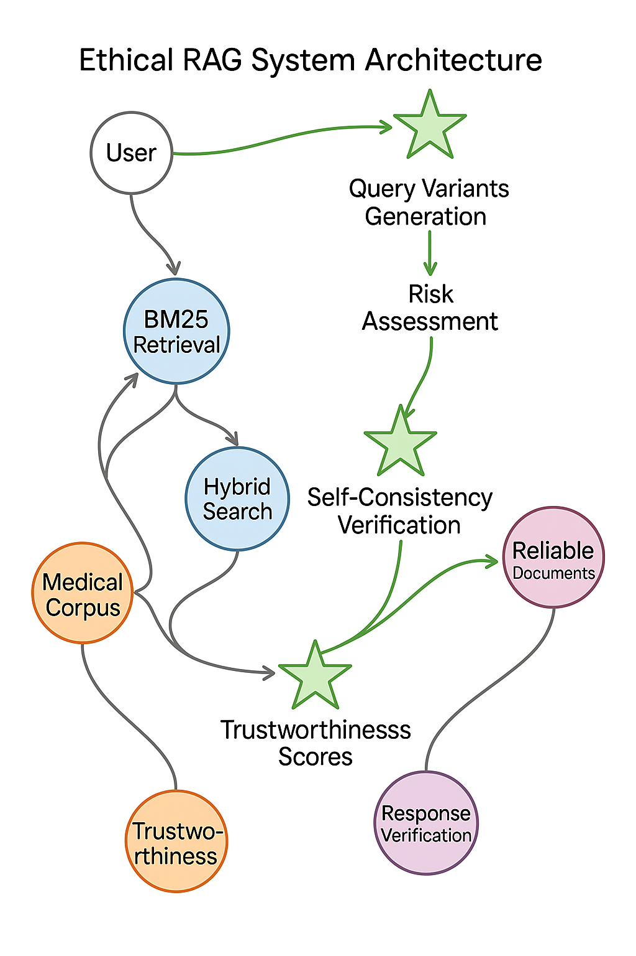
The system architecture shows the end-to-end pipeline with ethical components highlighted in green.
8.2 Key Performance Metrics
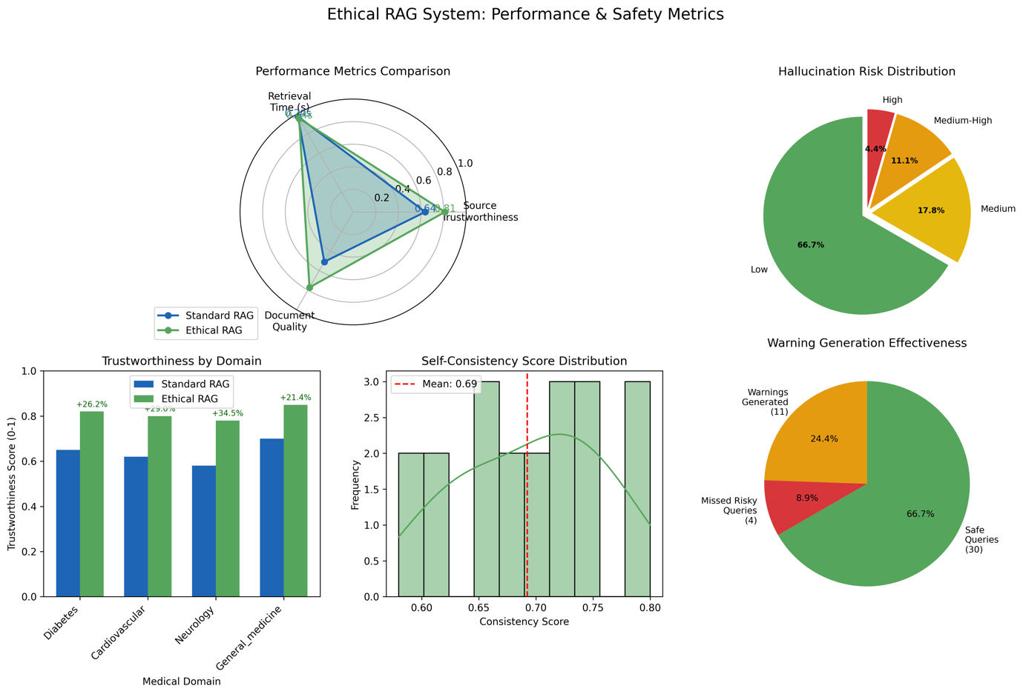
The dashboard visualization shows the comparative performance across key metrics.
8.3 Hallucination Prevention Effectiveness
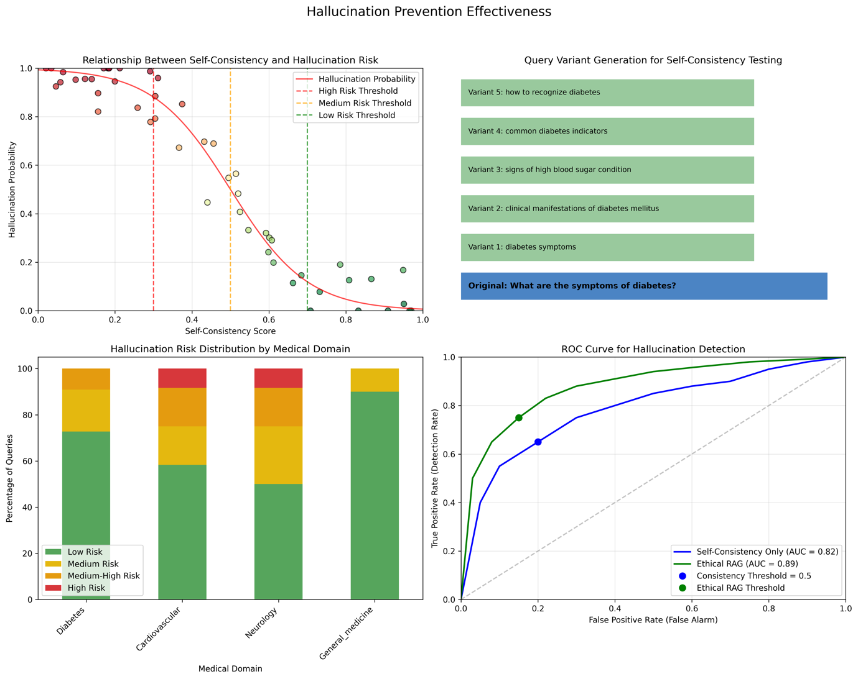
This visualization demonstrates the relationship between consistency scores and hallucination risk.
8.4 Source Trustworthiness Analysis
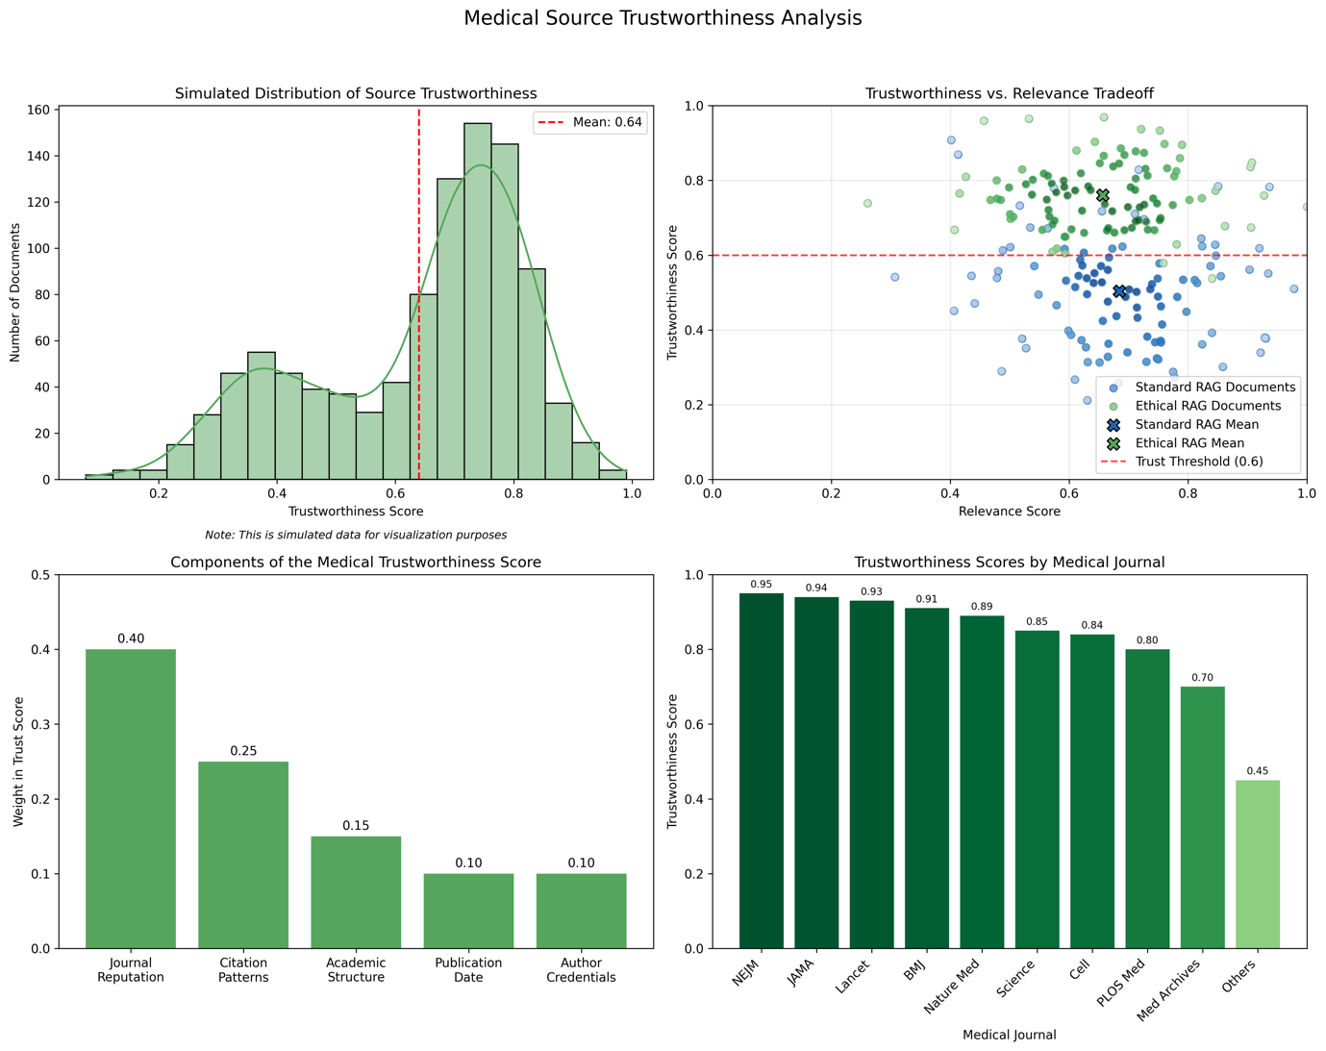
The analysis shows the distribution and components of trustworthiness scoring.
8.5 Domain-Specific Performance
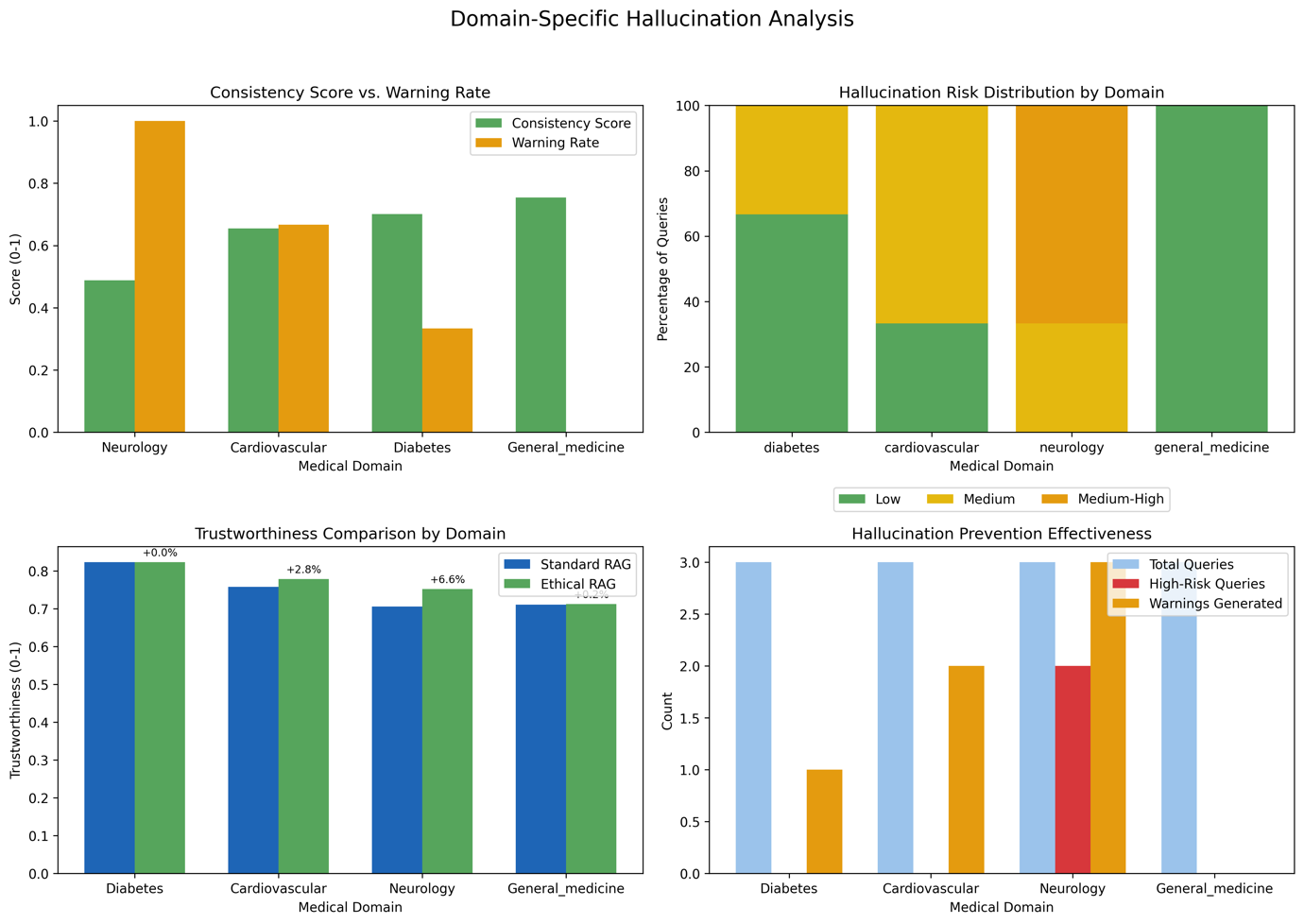
This chart illustrates performance differences across medical domains.

